The script uses a SwitecX25 stepper motor to physically move a needle to an "In Zone" position when my focus level hits a threshold of 70, giving me that non-intrusive peripheral feedback I wanted. At the same time, it controls a 7-bit WS2812B LED ring on pin D9 to create a "breathing" amber light effect, which serves as a social signal to tell others I’m in a deep work state. In its default state, the motor stays at a "Ready" position, and the LEDs remain off to keep my environment distraction-free.

One Photo of Functional Breadboard, Perfboard, or PCB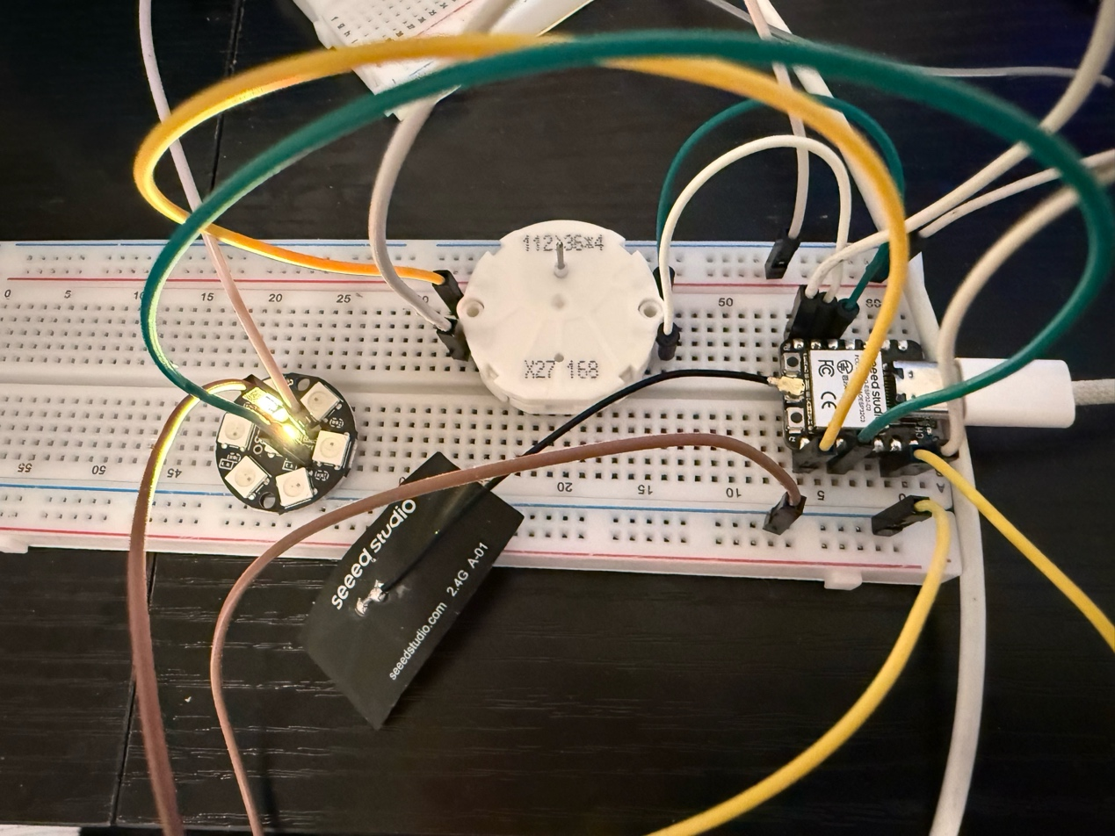

Two screenshots of CAD Model
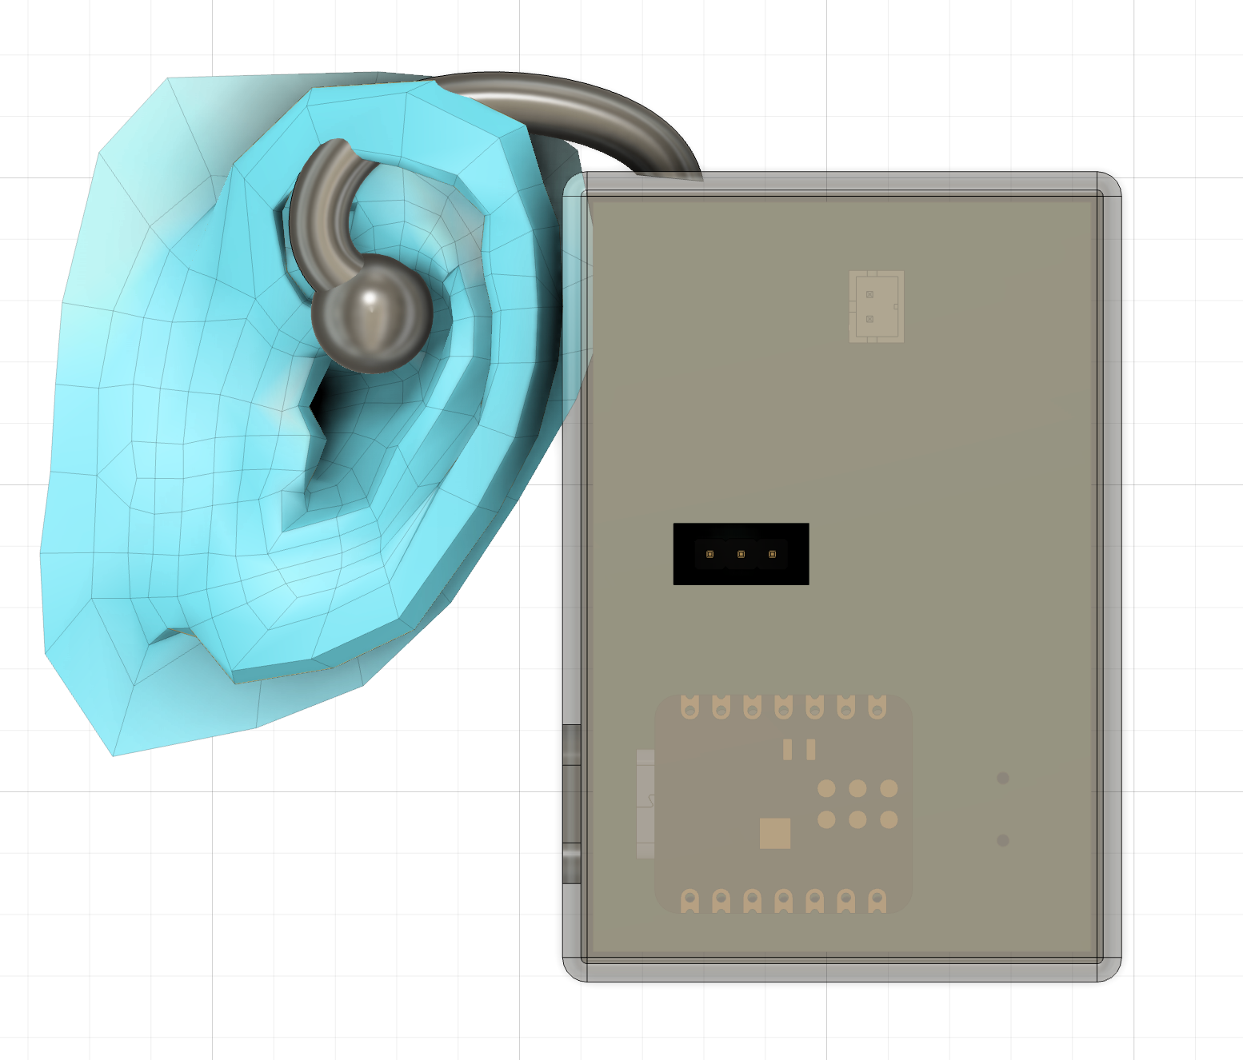
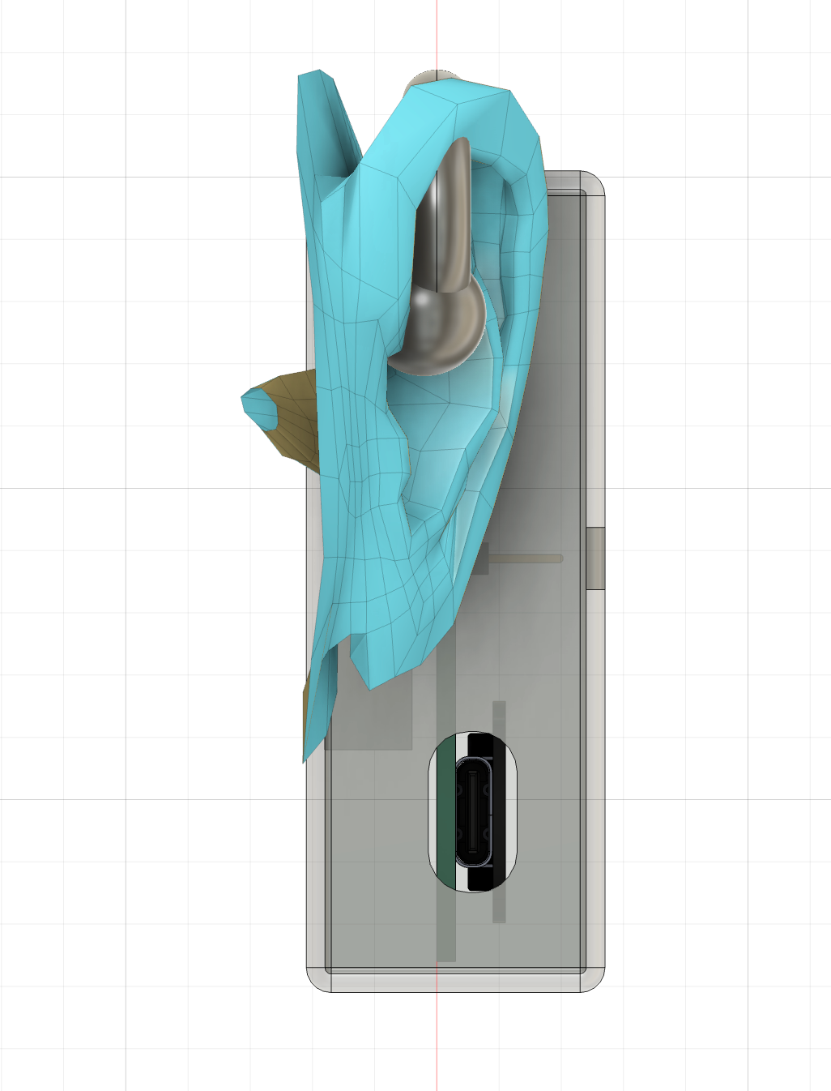

Link to code in Github
https://github.com/jwei2000-code/FinalProject/tree/main/code/display
#include <SwitecX25.h>
#include <Adafruit_NeoPixel.h>
#include <BLEDevice.h>

// --- Configuration ---
#define LED_PIN D9
#define NUM_LEDS 7
#define STEPS 945
#define IN_ZONE_POS 800
#define READY_POS 100

// IMPORTANT: use ESP32 GPIO numbers that you wired through a driver (ULN2003/transistors)
// XIAO ESP32C3 example pins (change to your actual wiring)
#define COIL1 4
#define COIL2 5
#define COIL3 6
#define COIL4 7

SwitecX25 motor(STEPS, COIL1, COIL2, COIL3, COIL4);
Adafruit_NeoPixel ring(NUM_LEDS, LED_PIN, NEO_GRB + NEO_KHZ800);

int focusLevel = 0;

void setup() {
Serial.begin(115200);

ring.begin();
ring.setBrightness(50);
ring.show();

motor.setPosition(READY_POS);
}

void loop() {
motor.update();

if (focusLevel >= 70) {
motor.setPosition(IN_ZONE_POS);
pulseLEDs(255, 120, 0);
} else {
motor.setPosition(READY_POS);
ring.clear();
ring.show();
}
}

void pulseLEDs(uint8_t r, uint8_t g, uint8_t b) {
float s = sin(millis() / 500.0f);
uint8_t brightness = (uint8_t)((s + 1.0f) * 127.0f);

for (int i = 0; i < NUM_LEDS; i++) {
ring.setPixelColor(i, ring.Color((r * brightness) / 255, (g * brightness) / 255, (b * brightness) / 255));
}
ring.show();
}

